API Query Parameters

🔍 What is API Query Parameters
# Source: AI Source: Provided by: [Data Path: Persons Table -> ID Column: 1, Name_En Column: Motasem Essam] -> From: [ChatGPT] on [1/19/2026]
API Query Parameters are key-value pairs added to the end of a URL that provide additional information, filters, or instructions to the server for processing the request.
👉 Think of query parameters as extra options for an API call that modify the response.

🔑 Key Points
# Source: AI Source: Provided by: [Data Path: Persons Table -> ID Column: 1, Name_En Column: Motasem Essam] -> From: [ChatGPT] on [1/19/2026]
- Appended to the URL after ?
- Multiple parameters are separated by &
- Used for filtering, sorting, paging, or specifying options
- Optional – not always required for a request

🧱 Example
# Source: AI Source: Provided by: [Data Path: Persons Table -> ID Column: 1, Name_En Column: Motasem Essam] -> From: [ChatGPT] on [1/19/2026]
URL with Query Parameters
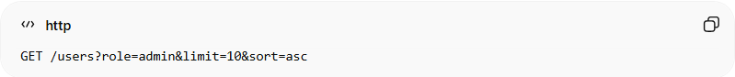
GET /users?role=admin&limit=10&sort=asc
Explanation
- role=admin → filter users by admin role
- limit=10 → return maximum 10 results
- sort=asc → sort results in ascending order
Response
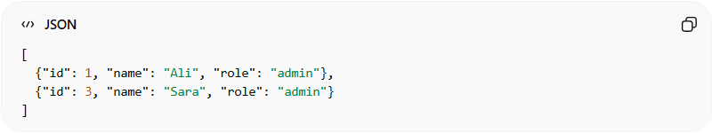
[
{"id": 1, "name": "Ali", "role": "admin"},
{"id": 3, "name": "Sara", "role": "admin"}
]

🔧 Common Uses of Query Parameters
# Source: AI Source: Provided by: [Data Path: Persons Table -> ID Column: 1, Name_En Column: Motasem Essam] -> From: [ChatGPT] on [1/19/2026]
- Filtering → ?status=active
- Pagination → ?page=2&limit=20
- Sorting → ?sort=createdAt
- Search / Search terms → ?q=John
- Optional settings → ?include=posts,comments

✅ Best Practices
# Source: AI Source: Provided by: [Data Path: Persons Table -> ID Column: 1, Name_En Column: Motasem Essam] -> From: [ChatGPT] on [1/19/2026]
- Use descriptive parameter names
- Keep parameter values URL-safe (encode if needed)
- Support default values if parameter is omitted
- Document all available parameters clearly

❌ Common Mistakes
# Source: AI Source: Provided by: [Data Path: Persons Table -> ID Column: 1, Name_En Column: Motasem Essam] -> From: [ChatGPT] on [1/19/2026]
- Using too many parameters in one request ❌
- Ignoring encoding for special characters ❌
- Returning inconsistent responses when parameters are missing ❌

💡 Summary
# Source: AI Source: Provided by: [Data Path: Persons Table -> ID Column: 1, Name_En Column: Motasem Essam] -> From: [ChatGPT] on [1/19/2026]
API Query Parameters allow clients to customize and filter API responses by sending additional information in the request URL.

